1. **Computer’s age**

a= str(input('Enter Your Name:'))

b= int(input('Enter Your Age: '))

c= str(input('Enter Your Gender: '))

d= int(15)

if b < 15:

print("Hello I'm The computer and my age is 15 hence I am older than you.")

if b > 15:

print("Hello I'm The computer and my age is 15 hence I am younger than you.")  
  
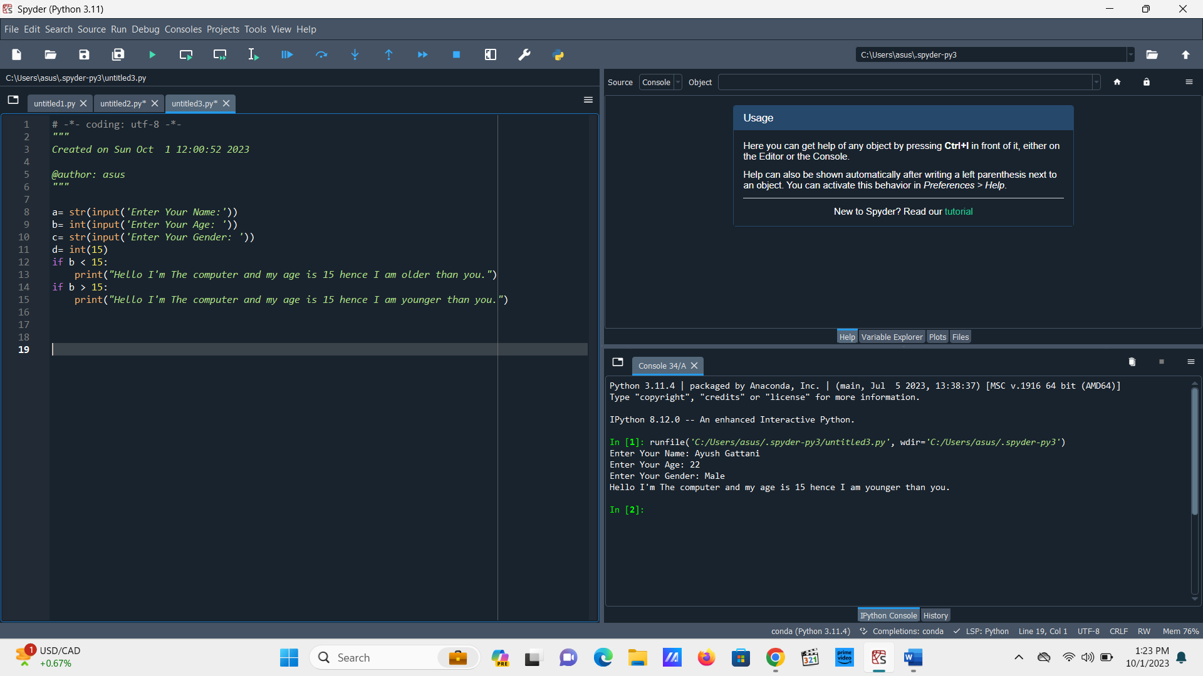

Another style of Computer Age by User Input

a= str(input('Enter Your Name:'))

b= int(input('Enter Your Age: '))

c= str(input('Enter Your Gender: '))

d= int(15)

if b < 15:

print('Hello',(a), 'I am The Computer and my age is 15 hence I am older than you.')

if b > 15:

print('Hello',(a), 'I am The computer and my age is 15 hence I am younger than you.') a= str(input('Enter Your Name:'))

2. Odd Even

num=4545

if num%2 == 0:

print('The number is even')

else:

print('The number is odd')

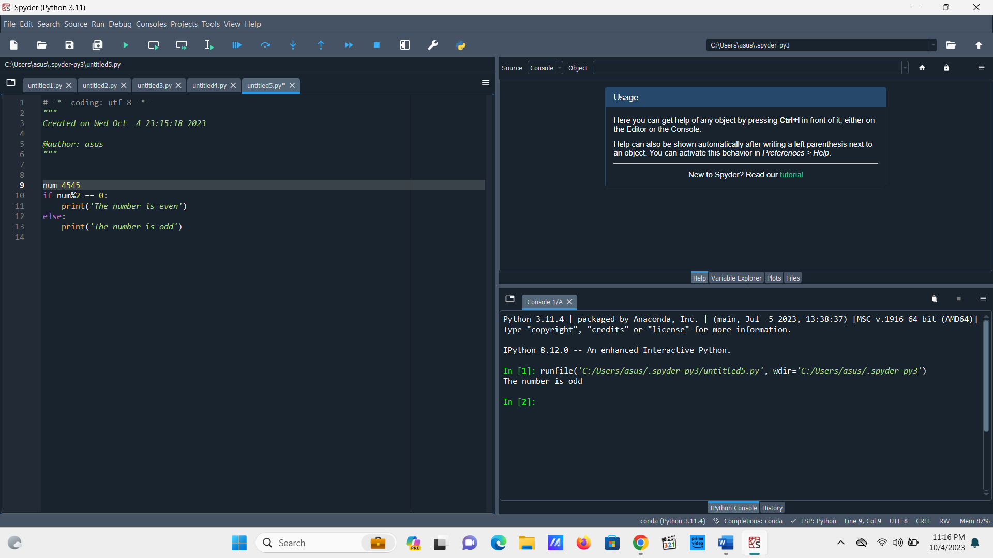

3. Odd Even by User Input

num=int(input('Enter a number:'))

if(num%2) == 0 :

print((num), 'is Even')

else:

print((num), 'is Odd')

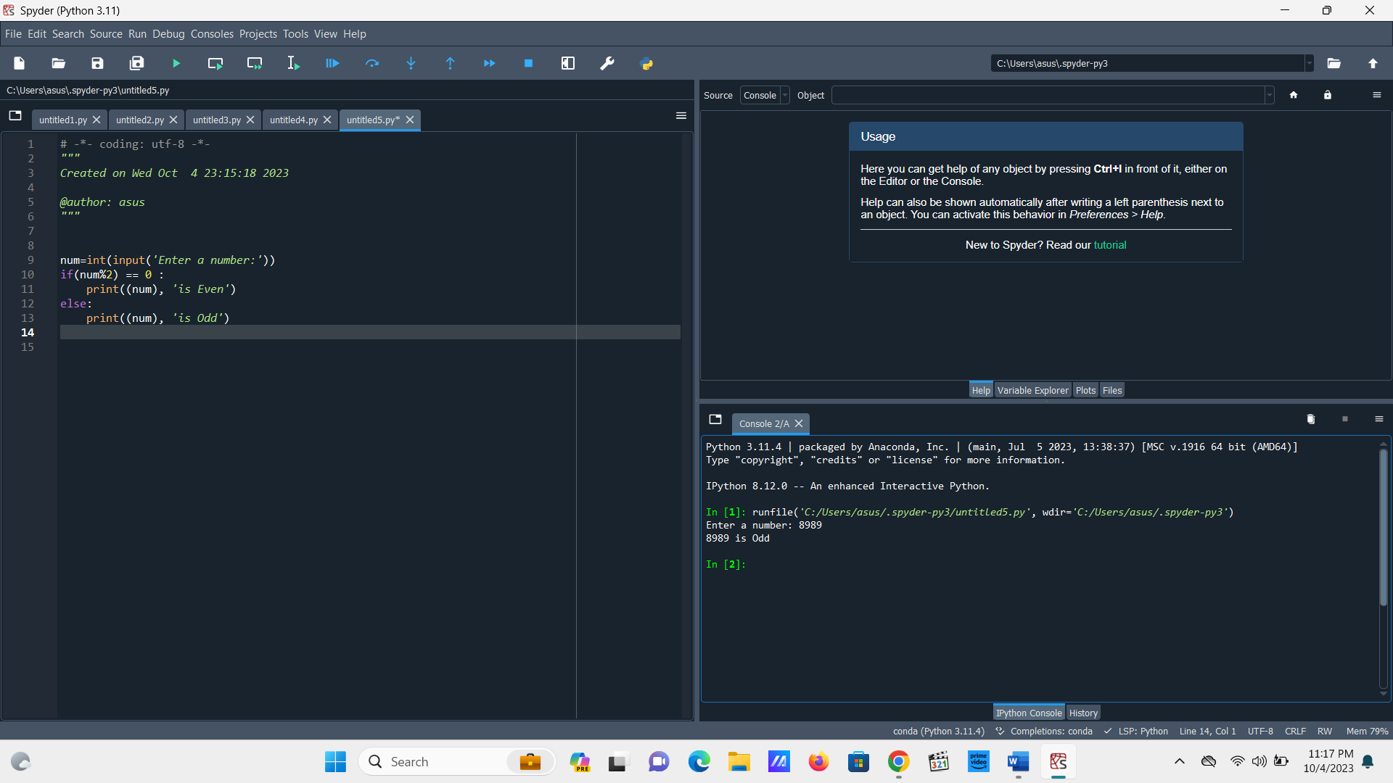

4. Decimal

d=float(input('Enter a number:'))

if d%1==0:

print('False')

else:

print('True')  
  
  
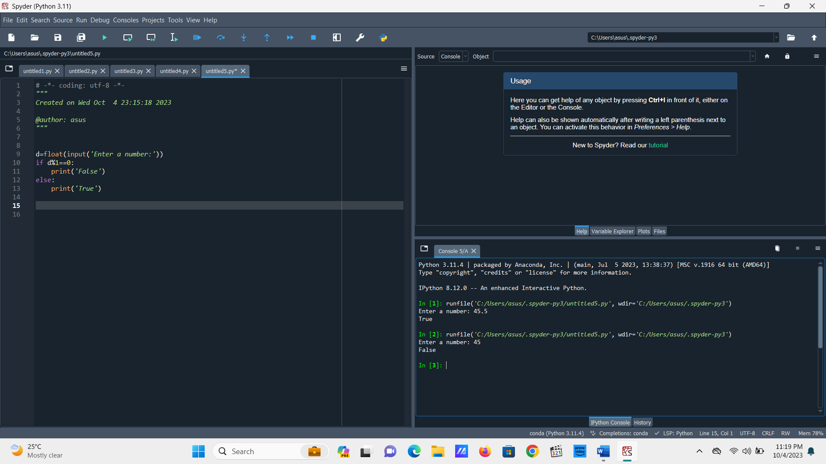

**5. Number Comparison**

a= float(input('Enter a number:'))

b= float(input('Enter a number:'))

if (a>b):

print('True')

else:

print('False')

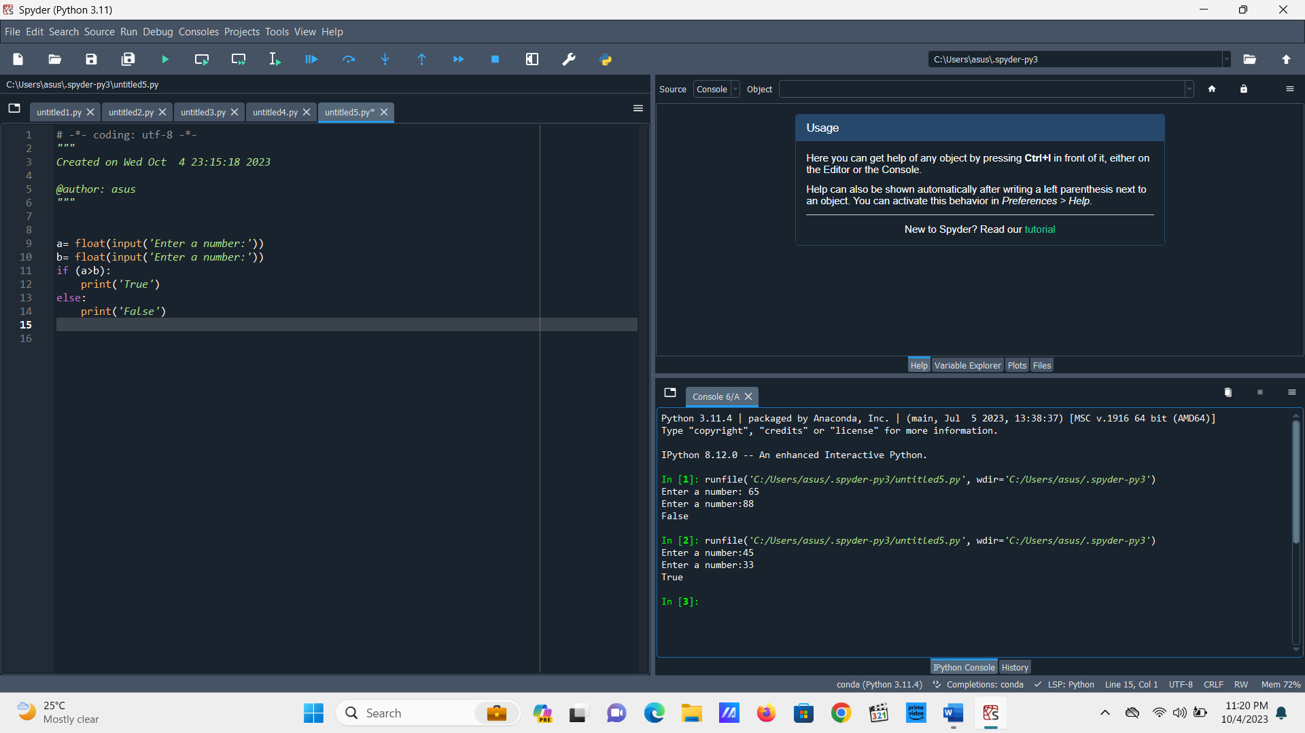

If A<B

a= float(input('Enter a number:'))

b= float(input('Enter a number:'))

if (a<b):

print('True')

else:

print('False')

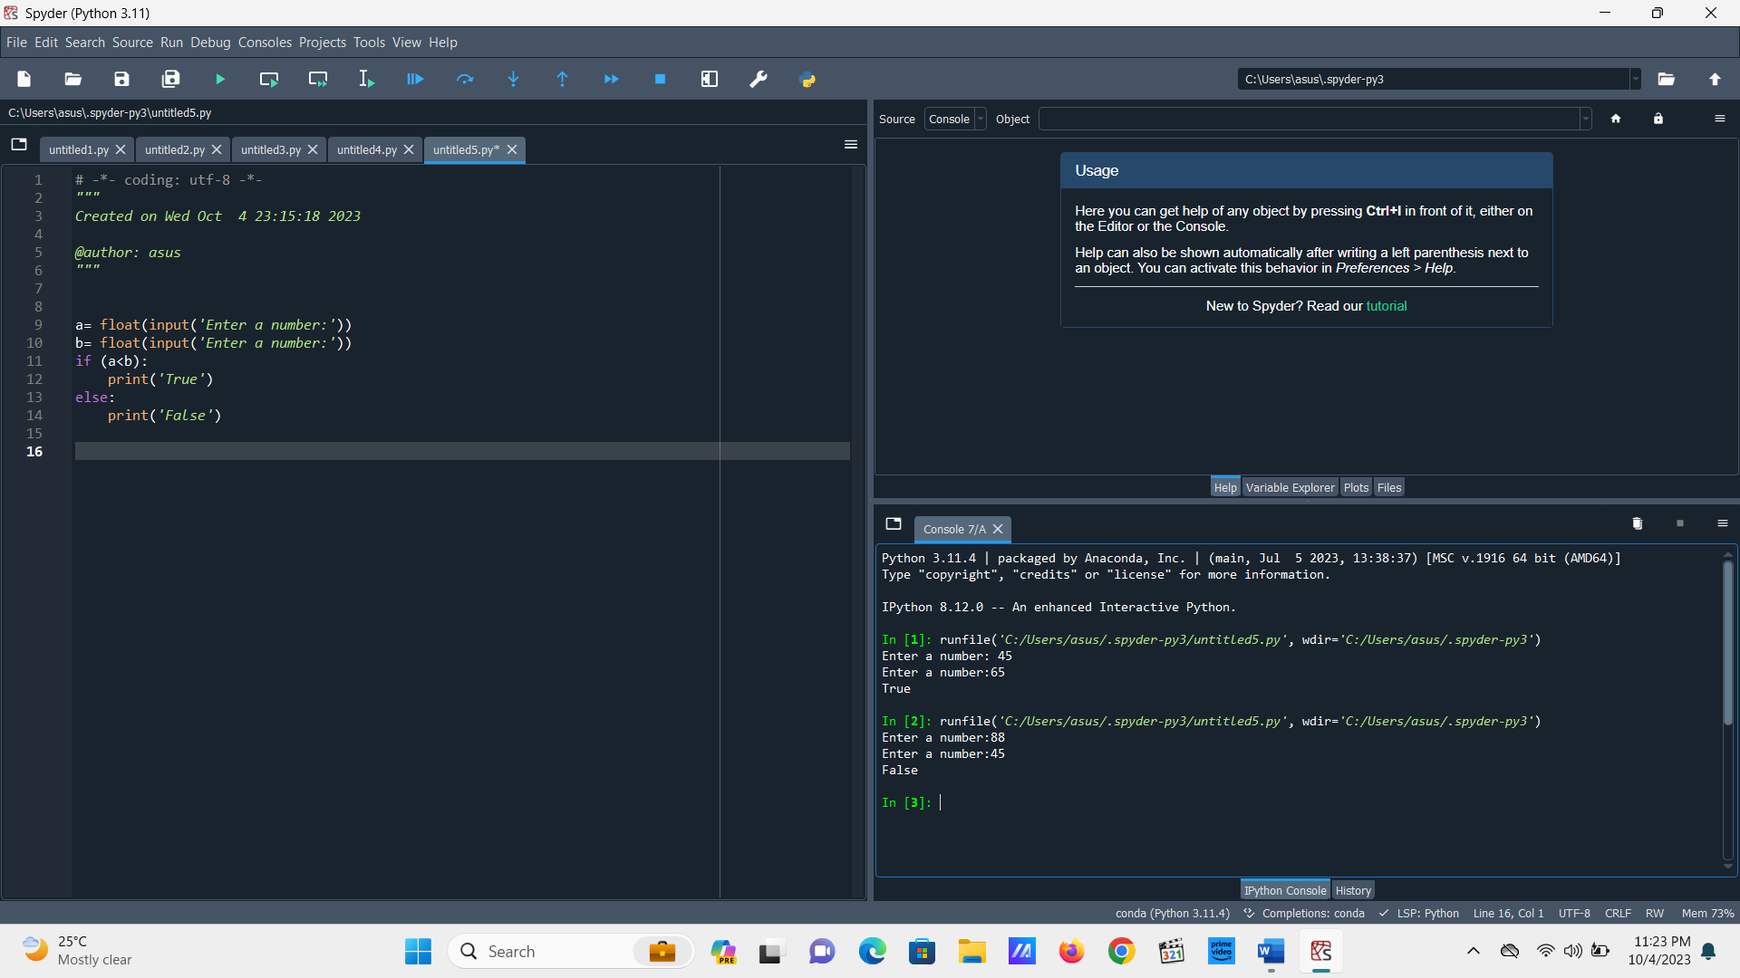

**If (a+b)>c**

a= float(input('Enter a number:'))

b= float(input('Enter a number:'))

c= float(input('Enter a number:'))

if (a+b)>c:

print('True')

else:

print('False')

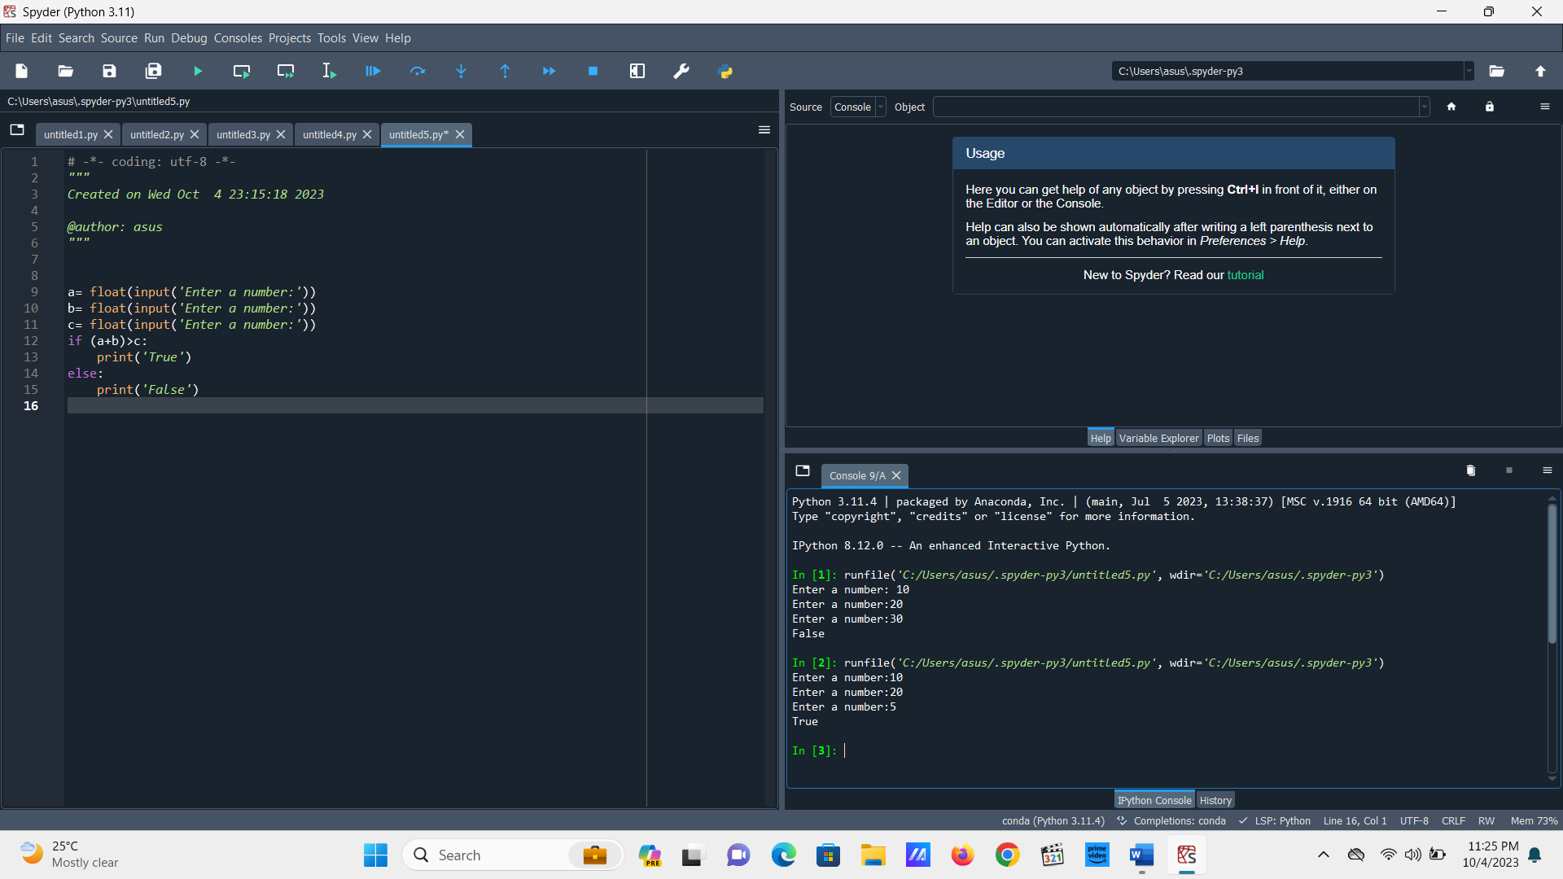

**If (a-b)<=c:**

a= float(input('Enter a number:'))

b= float(input('Enter a number:'))

c= float(input('Enter a number:'))

if (a-b)<=c:

print('True')

else:

print('False')

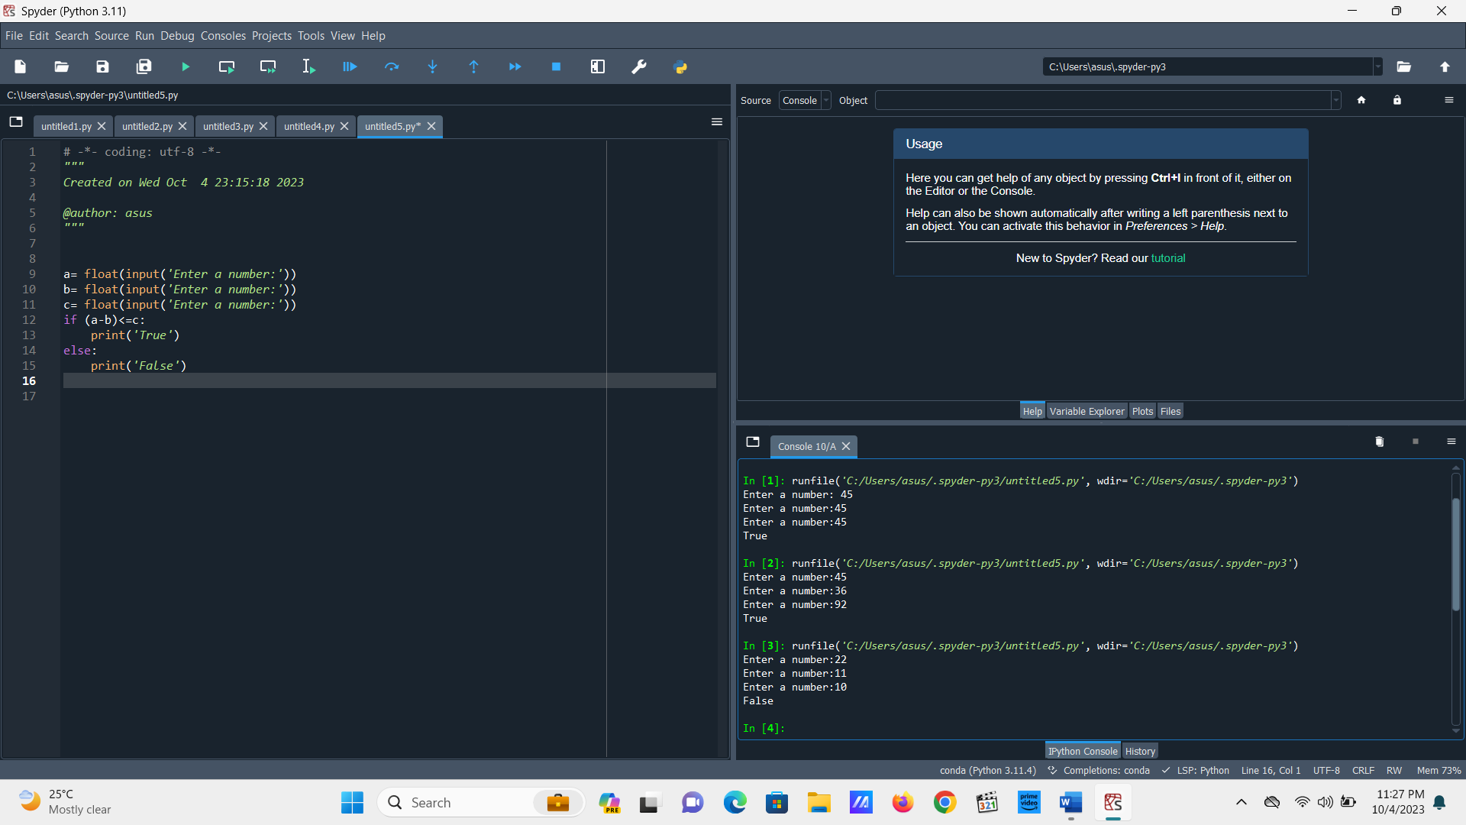

**Equal and non equal numbers**

a= float(input('Enter a number:'))

b= float(input('Enter a number:'))

if (a==b):

print('Equal')

if (a!=b):

print('Not Equal')

6. Leap Year Number Check

year=int(input('Enter a year:'))

if (year%4) == 0:

print('It is a leap year')

else:

print('It is not a leap year')

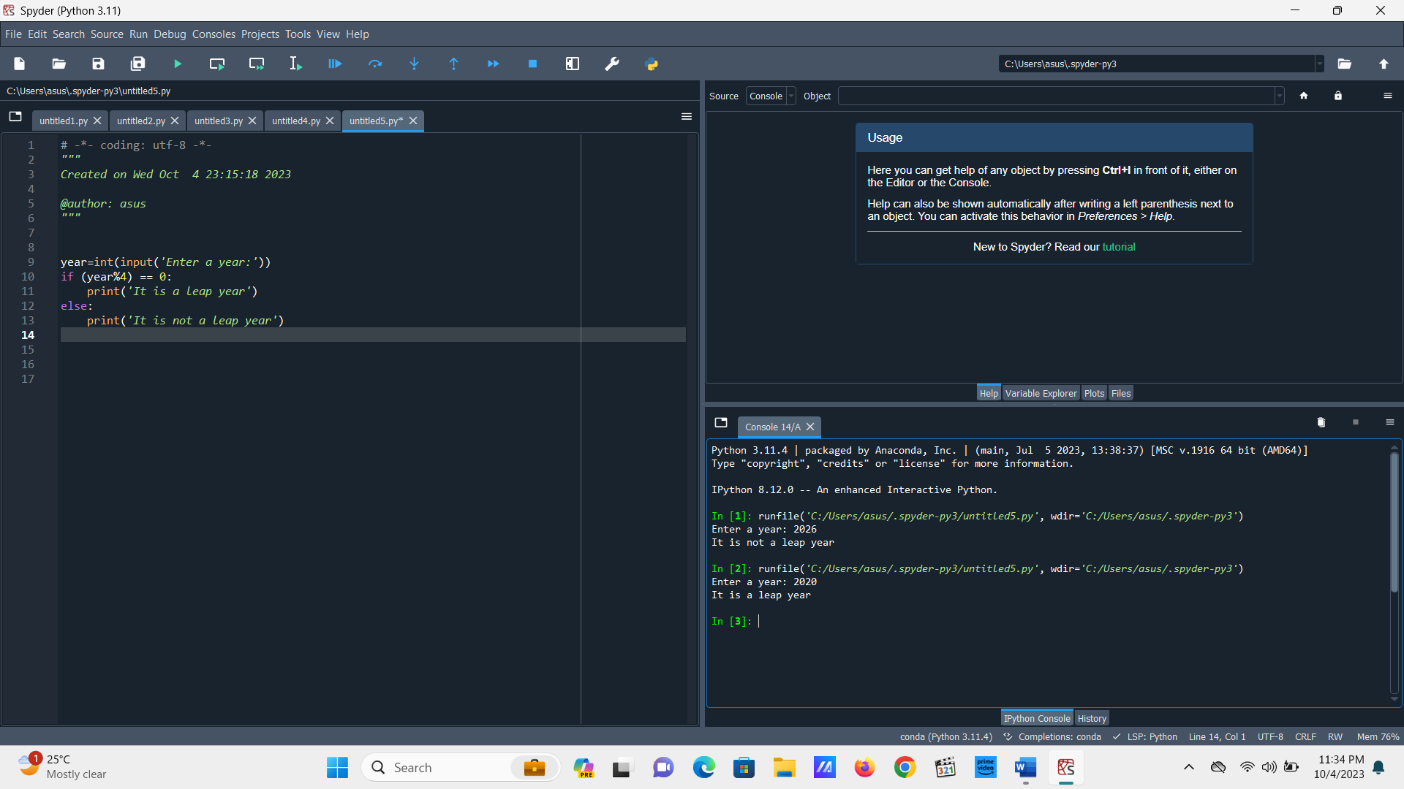

Q-**Speed of a = 7m/sec , Speed of b = 3/sec. B has an extra start of 4 sec. When will they two meet?**

a=int(input('Enter the speed:'))

b=int(input('Enter the speed:'))

c=int(input('how many seconds prior does b started:'))

d=int(b*c)/(a-b)

print('a and b will meet after', d ,'sec.')

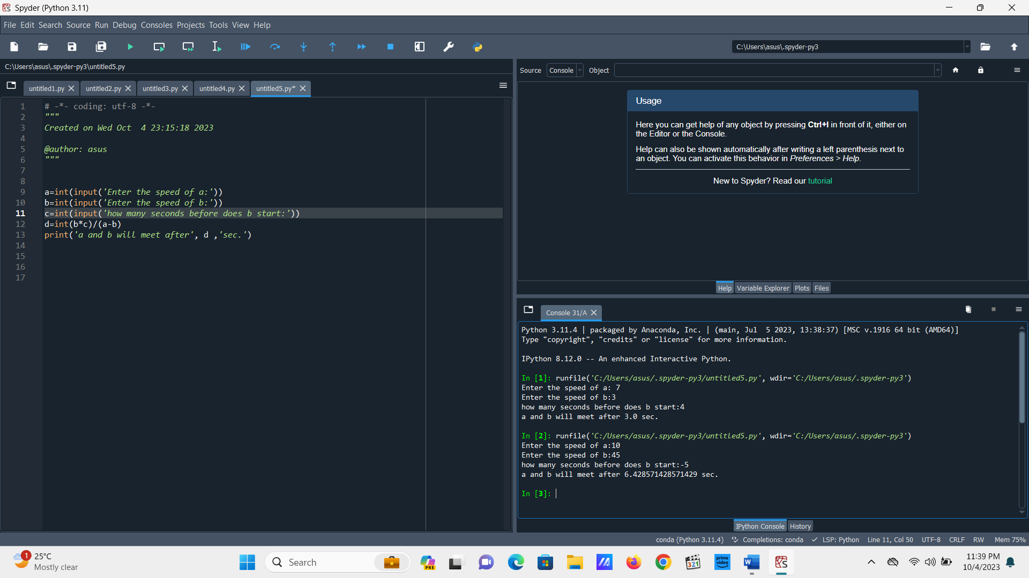

7. **POSITIVE OR NEGATIVE CHECK :-**

n=int(input('Enter a number:'))

if n>0:

print('The number is positive')

else:

print('The number is negative')

